

Practices for Secure Software Report

Table of Contents
Document Revision History 3
Client 3
Instructions 3
Developer 4
1. Algorithm Cipher 4
2. Certificate Generation 4
3. Deploy Cipher 4
4. Secure Communications 4
5. Secondary Testing 4
6. Functional Testing 4
7. Summary 4
8. Industry Standard Best Practices 4

Document Revision History

Version | Date | Author | Comments
1.0 | 08/13/2026 | Sarah Hwair | Project Two secure software report

Client



Instructions

Submit this completed practices for secure software report. Replace the bracketed text with the relevant information. You must document your process for writing secure communications and refactoring code that complies with software security testing protocols.

- Respond to the steps outlined below and include your findings.
- Respond using your own words. You may also choose to include images or supporting materials. If you include them, make certain to insert them in all the relevant locations in the document.
- Refer to the Project Two Guidelines and Rubric for more detailed instructions about each section of the template.

Developer
Sarah Hwair

Algorithm Cipher

For Artemis Financial, I recommend AES-256 as the primary symmetric encryption cipher for protecting sensitive financial data, together with SHA-256 for the required checksum verification. AES is the Advanced Encryption Standard defined in NIST FIPS 197. It is a symmetric block cipher, which means the same secret key is used to encrypt and decrypt information. AES processes 128-bit data blocks and supports 128-, 192-, and 256-bit keys. AES-256 uses a 256-bit key and provides a strong security margin for confidential customer and financial information.
The checksum requirement is different from encryption because a cryptographic hash is one-way and is not designed to be decrypted. I used SHA-256 from the SHA-2 family. SHA-256 accepts data of varying length and produces a fixed 256-bit (32-byte) message digest, commonly displayed as 64 hexadecimal characters. If the transferred data changes, the resulting digest also changes, allowing Artemis Financial to verify data integrity.
AES uses a symmetric key, while certificates and TLS use asymmetric cryptography for identity and protected key establishment. The self-signed certificate for this project uses an RSA 2048-bit public/private key pair and a SHA-256 signature. Random numbers are also essential in cryptography because keys, nonces, and initialization values must be unpredictable. Production systems should use cryptographically secure random-number generation.
Historically, older algorithms such as DES became inadequate as computing power increased. NIST standardized AES in 2001 after selecting Rijndael to replace DES for modern data protection. SHA-1 has also been deprecated for security-sensitive uses because collision attacks weakened its reliability. AES and the SHA-2 family remain standardized and widely used choices. For this project, AES-256 is appropriate for confidentiality, while SHA-256 directly satisfies the checksum and integrity-verification requirement.

Certificate Generation
Insert a screenshot below of the CER file.
I generated a self-signed certificate with Java Keytool using the alias artemisfinancial. The certificate uses a 2048-bit RSA key pair, SHA256withRSA signature algorithm, and a PKCS12 keystore. I exported the public certificate as artemisfinancial.cer. The screenshot below should show the exported CER file or its certificate details.

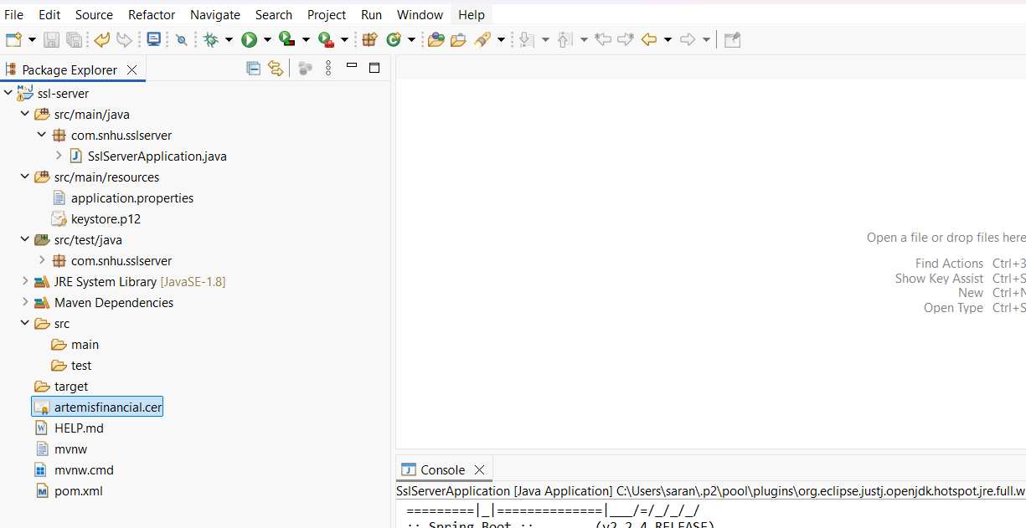

Deploy Cipher
Insert a screenshot below of the checksum verification.
I implemented SHA-256 in the /hash route using Java MessageDigest. The unique data string is “Sarah Hwair - Artemis Financial Secure Data.” The expected SHA-256 checksum is aa6906b9140184a329d8417ce68fea242b90848bf81aa701f39a131e538b2fd0. The screenshot below should show the running application displaying my name, the unique data string, and the checksum.

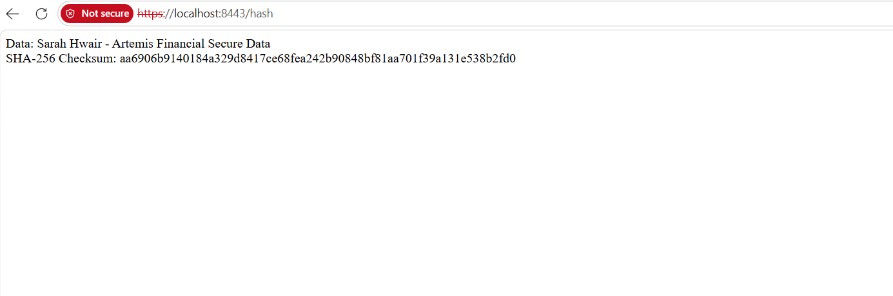

Secure Communications
Insert a screenshot below of the web browser that shows a secure webpage.
I enabled SSL in application.properties, configured the server to use port 8443, and linked the PKCS12 keystore to the application. I then ran the Spring Boot application and opened https://localhost:8443/hash to verify that the endpoint was delivered over HTTPS. Because this project uses a self-signed certificate, the browser may display a development certificate warning before opening the page.



Secondary Testing

The OWASP Dependency-Check completed successfully and identified 13 vulnerable dependencies with 213 known vulnerabilities in the existing dependency set. My SHA-256 refactoring used Java standard-library classes and did not add new third-party dependencies. Therefore, these findings were associated with the inherited application dependencies rather than new dependencies introduced by my checksum implementation.
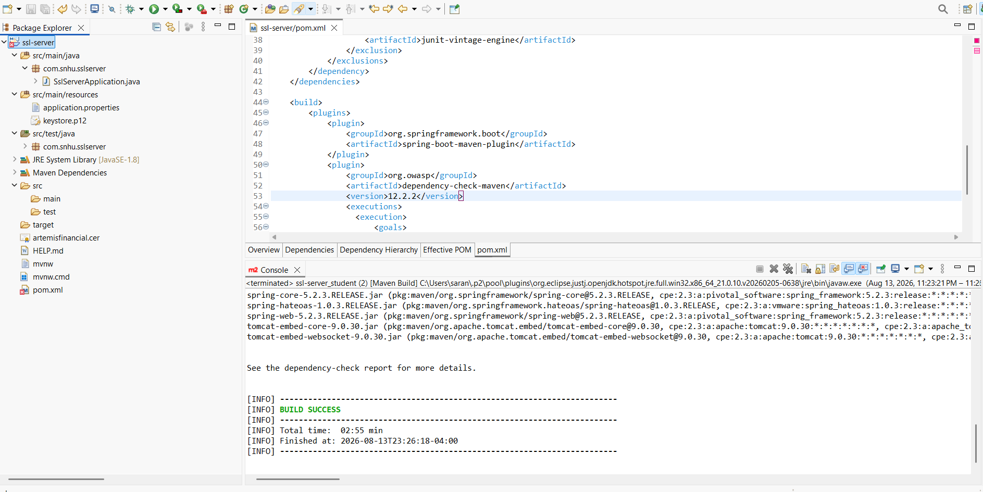
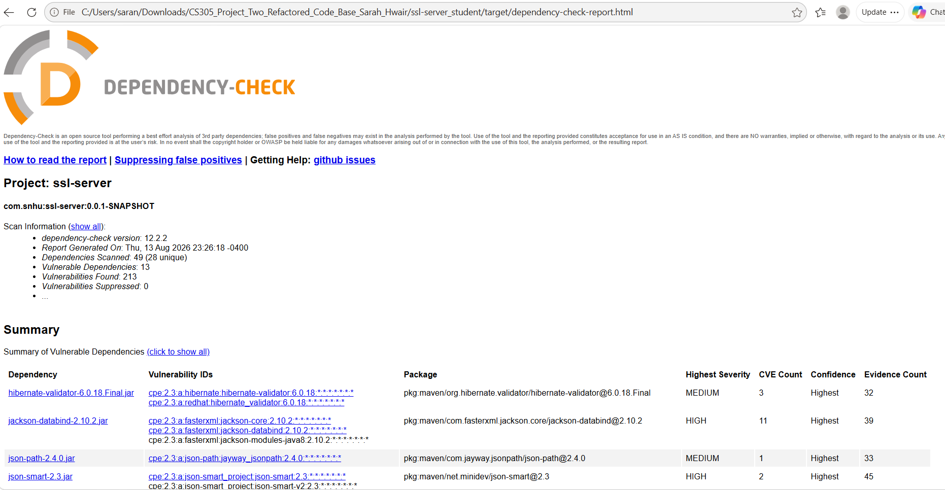

Functional Testing
Insert a screenshot below of the refactored code executed without errors.
I manually reviewed the Java and configuration files for syntax, logic, and security issues. I verified that the /hash route executes, that the same input consistently produces the same 256-bit SHA-256 digest, and that the server is configured for HTTPS on port 8443. I also confirmed that UTF-8 is used for the hashed string and that no unnecessary dependency was added for checksum functionality.

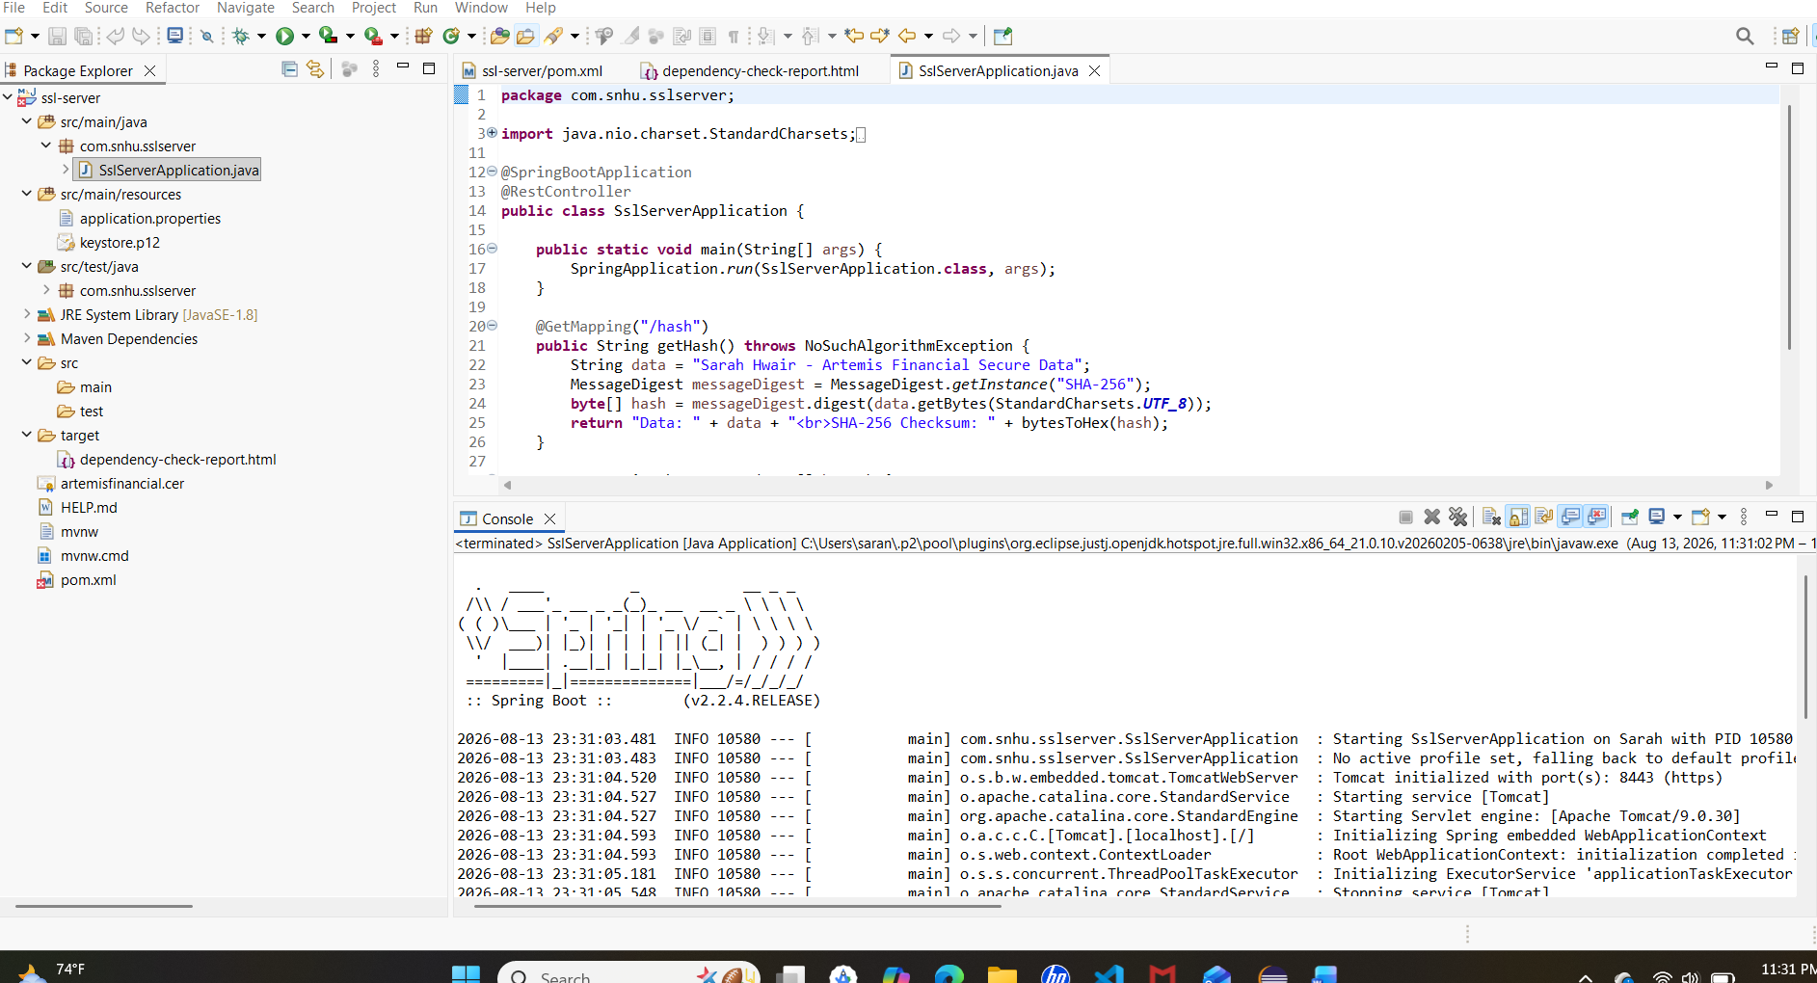

Summary

I refactored the Artemis Financial application by adding multiple layers of security instead of relying on one control. First, I added a /hash endpoint that creates a SHA-256 checksum for a unique data string containing my name. This addresses integrity by providing a repeatable cryptographic digest that can detect changes to data. Second, I generated a self-signed certificate and configured the Spring Boot application to use it through a PKCS12 keystore. Third, I configured the server to use port 8443 with SSL enabled so communication occurs through HTTPS rather than unencrypted HTTP.
Using the vulnerability-assessment process as a guide, the refactoring focused on cryptography, secure communications, data integrity, code quality, dependency review, and testing. I manually reviewed the code for syntax and logic problems, ran the application to verify the refactored code executed, and used OWASP Dependency-Check as a secondary static test. Dependency scanning is important because a secure feature can still be exposed if the application relies on vulnerable third-party components.
The security layers work together: SHA-256 helps verify integrity, the certificate supports TLS, HTTPS protects data in transit, and dependency/static testing reviews supporting components. This defense-in-depth approach reduces the chance that one weakness will compromise the entire application. No new third-party library was needed for the checksum implementation, which also reduced the possibility of introducing a new dependency vulnerability during the refactoring.

Industry Standard Best Practices

I applied secure-coding best practices by using established, standardized cryptographic algorithms rather than creating a custom cipher or hash method. The checksum uses Java's MessageDigest implementation of SHA-256 and UTF-8 encoding so the same input is processed consistently. I also used HTTPS instead of plain HTTP and stored the TLS key material in a keystore rather than embedding a private key in Java source code. The development certificate includes localhost as the subject and subject alternative name so it matches the host used for testing.
I preserved the application's existing functionality while making focused security changes. The new /hash route does not require an additional external library, which minimizes attack surface and avoids unnecessary dependencies. I reviewed dependency-check results to separate issues in the inherited code base from issues introduced by my refactoring. In a production environment, I would also use a certificate issued by a trusted certificate authority, protect keystore passwords with environment variables or a secret-management system, rotate keys and certificates, maintain supported framework versions, and apply security updates based on risk.
Industry-standard secure coding has business value because Artemis Financial handles sensitive financial and client information. Following established standards improves confidentiality, integrity, and trust, reduces the chance of preventable security incidents, and makes security controls easier for future developers to review and maintain. It also supports Global Rain's principle that security is everyone's responsibility by making security part of design, implementation, testing, and maintenance.

Technical Configuration Used
Unique data string: Sarah Hwair - Artemis Financial Secure Data
Hash algorithm: SHA-256
Expected checksum: aa6906b9140184a329d8417ce68fea242b90848bf81aa701f39a131e538b2fd0
HTTPS port: 8443
Certificate alias: artemisfinancial
Keystore type: PKCS12
Certificate key/signature: RSA 2048-bit / SHA256withRSA

AI Usage Acknowledgment
I used AI as a support tool to help organize the project steps, explain secure-coding concepts, and draft portions of the code and report language. I reviewed the generated material, compared it with the course requirements, and am responsible for testing, revising, and submitting the final work.

Standards Referenced
National Institute of Standards and Technology (NIST), FIPS 197: Advanced Encryption Standard (AES).
National Institute of Standards and Technology (NIST), FIPS 180-4: Secure Hash Standard (SHS).

